Humanitarian project
"Chernobyl in our memory..."

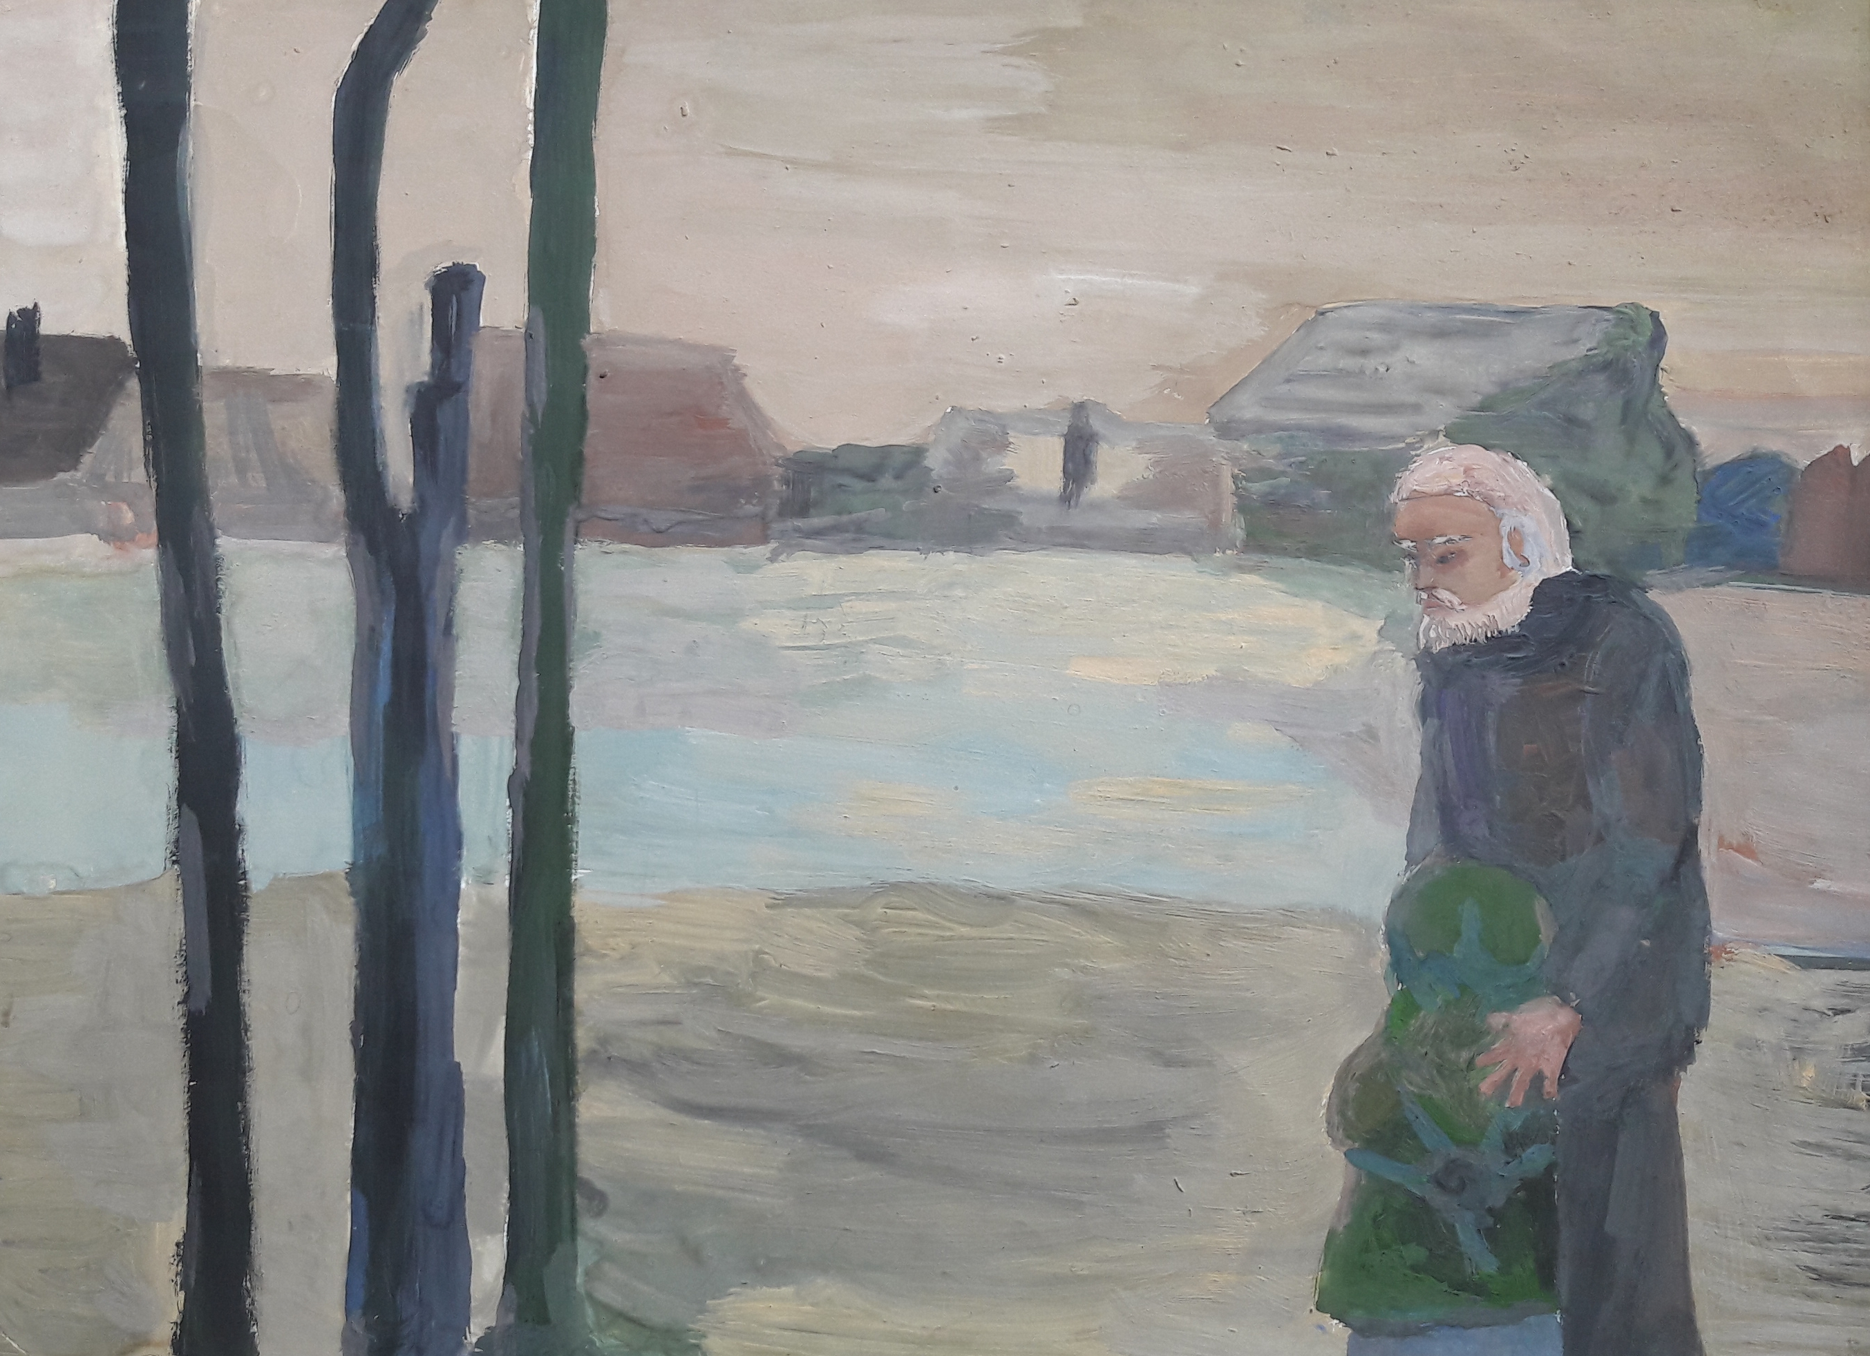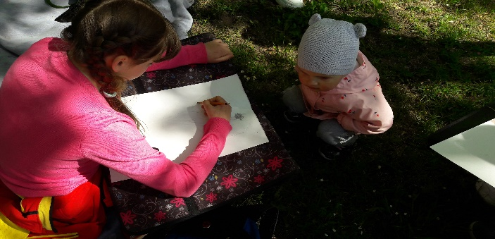

1. Name of the project: “Chernobyl in our memory…”
2. Project implementation period: 1 year from the start of implementation
3. Applicant organization proposing the project: State Educational Institution "Novogrudok Children's Art School"
4. Objective of the project:
- providing residents of the settlements of the Novogrudok district, located in the areas affected by the Chernobyl tragedy, with cultural and educational activities aimed at maintaining a peaceful and safe life.
5. Tasks planned for implementation within the framework of the project:
- civil and patriotic education of the younger generation;
- attracting the older population to an active lifestyle and full participation in society.
6. Target group:
local residents of the agro-town Vselyub, the agro-town Otminovo, Novogrudok district, Grodno region.
7. Brief description of activities within the project:
- Conducting optional master classes for all age categories of the population of agro-towns in the direction of activity "Painting", "Arts and crafts" with the subsequent organization of an exhibition of completed works
- Organization of the cycle of literary and musical compositions "Echo of Chernobyl";
- Open Art Festival of children's drawings "Chernobyl in the memory and in the drawings of children" among school-age students of the agro-town Vselyub and the agro-town Otminovo;
- Exhibition-presentation of the best creative works, winners of the festival, holding an awards ceremony;
- Preparation and publication of the booklet "Chernobyl in our memory ..." with the placement of the best creative works.
8.Total funding (in US dollars):
Source of financing | Funding volume  (in US dollars) "Chernobyl in our memory"
Donor funds | 2000 USD
Co-financing | 200 USD
9. Location of the project (region/district, city):
Grodno region, Novogrudok, Mitskevicha, 9
10. Contact person: Lyudmila Ivanovna Aniskina, director of the school, tel..+37529 335 39 74, (801597) 4 77 14; E-mail: ndshi@novkultura.by,
school website: ndshi.nov-centr.of.by

